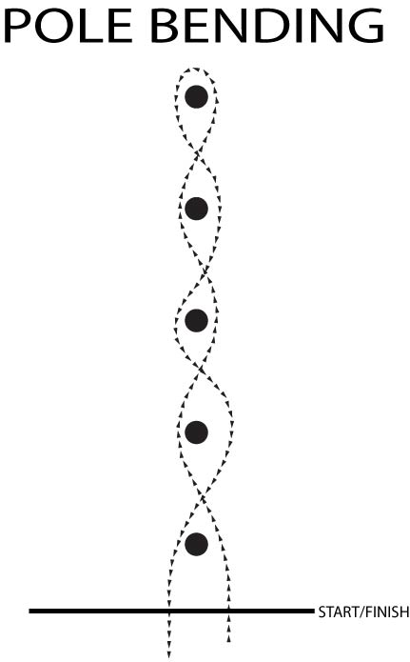

Distance between poles
6.4 mt

Distance from start to first pole
6.4 mt

